Archer, William (1856-1924)

Born in Edinburgh, William Archer served as a London theatre critic from 1881 to 1920. He retired from weekly reviewing when his melodrama The Green Goddess was a major success in New York (1920-22) and London (1923-24). His published translations of Henrik Ibsen’s plays began to appear in 1888 and culminated in The Works of Henrik Ibsen (12 volumes, 1906-08). He translated and helped to stage the first London productions of A Doll’s House (1889), Ghosts (1891), and Rosmersholm (1892), and in close partnership with the actress Elizabeth Robins, he co-directed the productions of Hedda Gabler (1891), The Master Builder (1893), Little Eyolf (1896), and John Gabriel Borkman (1898). He also translated and published plays by Maurice Maeterlinck and Gerhart Hauptmann. In his advocacy for modern English drama, Archer supported the plays of Arthur Wing Pinero, Oscar Wilde, James Barrie, Harley Granville Barker, and Bernard Shaw. He led the British campaigns against stage censorship and for a national theatre. In 1907, he and Barker published A National Theatre: Scheme and Estimates. In the mid-1880s, he and Shaw drafted a play entitled Rhinegold that Shaw later transformed into Widowers’ Houses (1892), the play that launched his playwriting career. Between 1892 and 1924, Archer wrote well over a hundred articles and reviews on Shaw and his plays. Although he criticized some of the plays, he repeatedly praised Shaw as a modern dramatic genius. Their abiding friendship thrived on their debates about all aspects of modern drama, including Shaw’s plays. In 1923, Archer published The Old Drama and the New, a historical survey of British drama with a lengthy (and still argumentative) section on Shaw.

List of Works

Archer, William. (1894-1898) The Theatrical World of 1893-1897, London: Walter Scott.

----- (1888) Masks or Faces? A Study in the Psychology of Acting, London: Longmans.

----- trans. and ed. (1906-08) The Works of Henrik Ibsen, 12 vols., London: Heinemann.

----- (1912) Playmaking: A Manual of Craftsmanship, London: Chapman & Hall.

----- (1923) The Old Drama and the New: An Essay in Re-Evalutation, London: Heinemann.

----- and H. Granville Barker (1907), A National Theatre: Scheme and Estimates, London: Duckworth.

Postlewait, Thomas, ed. (1984) William Archer on Ibsen, Westport: Greenwood.

-----, ed. (forthcoming 2015) Correspondence of Bernard Shaw and William Archer, Toronto: University of Toronto Press.

References and Further Reading

Archer, Charles. (1931) William Archer, London: Unwin.

Postlewait, Thomas. (1986) Prophet of the New Drama: William Archer and the Ibsen Campaign, Westport: Greenwood.

Whitebrook, Peter. (1993) William Archer, London: Methuen.

Thomas Postlewait, University of Washington

Recommended Illustrations:
[Please use two illustrations if possible (the cartoon and one of the two suggested portraits), but two is not possible, please prioritize the cartoon first and then one of the portraits of Archer, preferably the sepia-toned one, which shows his face better.]

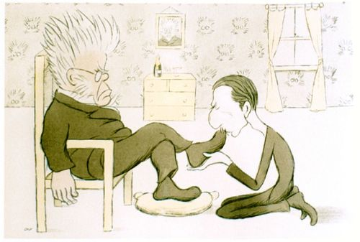

‘Henrik Ibsen receiving Mr William Archer in Audience,’ cartoon by Max Beerbohm.
[This image is available at http://britishlibrary.typepad.co.uk/european/2013/09/page/2/#sthash.UlGZNrUx.dpuf
where the the copyright is given as Museum and Study Collection at Central Saint Martin’s College of Art and Design]

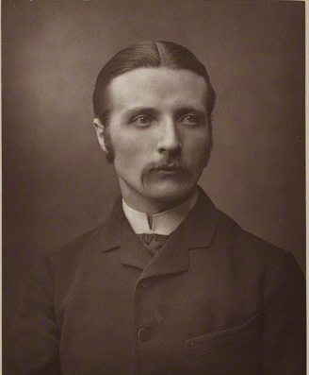

William Archer
[Available at National Portrait Gallery: http://www.npg.org.uk/collections/search/portrait/mw146102/William-Archer?LinkID=mp57666&role=sit&rNo=0]

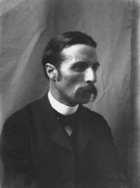

William Archer
[This is a low-resolution version of the portrait of Archer used in the Oxford dictionary of National Biography: (http://www.oxforddnb.com.ezproxy.lib.ucalgary.ca/templates/image-pop.jsp?id=30435&orientation=p)
The Oxford DNB lists the National Portrait Gallery as the copyright holder of the image.]

